**Physic of CT 3** 姓名: 燈號:

Q1. If the CTDIw is 20 mGy, and the CT scaning pitch is 2, what is the CTDIvol?

1. 40 mGy
2. 30 mGy
3. 20 mGy
4. 10 mGy

**Answer: D**

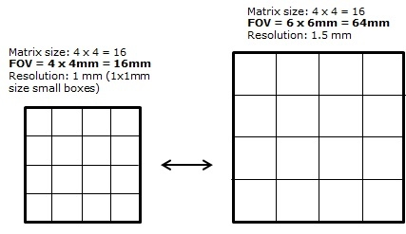.

<https://sites.google.com/site/frcrphysicsnotes/mr-image-quality>

|  |  |  |  |
| --- | --- | --- | --- |
|  | 單位 | 換算 | Note |
| Exposure | Roetgen, R  C/kg |  | 主要描述在空氣中輻射場強度  describes the ability of x-ray photons to ionize air |
| Absorbed dose, D | Gray, Gy  Rad  J/kg | 1Gy = 100 Rad | 表示物質吸收的輻射能量 |
| Equivalent dose, H | Sieverts, Sv  Rem  J/kg | H = D x WR  1Sv = 100Rem | - quality factor  - Xray, gamma ray, beta-particles, WR=1  - Alpha particle, WR =20  - Neutron, WR = 2.5-20 |
| Effective dose, E | Sieverts, Sv  Rem | E = H x WT  1Sv = 100Rem | Sum of Equivalent dose x weighting factor for each organ/tissue  - based on stochastic factor  - NOT on deterministic factor |